Abstract
This study examines whether localized ZEV adoption rates correlate with the persistence of NO2 and PM2.5 reductions across 20 Southern California cities (2021-2024). Using EPA AirData, California Energy Commission vehicle records, Census ACS income, and CalEnviroScreen 4.0 scores, I estimate four OLS panel models with year fixed effects. To address severe collinearity, I apply the Frisch-Waugh-Lovell theorem to residualize ZEV adoption and CES scores with respect to pollutants across all specifications. ZEV adoption is not associated with air quality improvement, as cities growing their ZEV fleets fastest are also the most traffic-intensive. The equity interaction is not significant, indicating no detectable difference in the ZEV effect across vulnerability quartiles. Residual analysis confirms that high-burden communities are systematically more polluted than predicted, pointing to heavy-duty freight as the mechanism sustaining environmental inequity beyond the reach of light-duty electrification policy.

Introduction
Breathing clean air in Southern California has never been equally distributed. Long before COVID-19, communities in the Inland Empire recorded some of the worst NO2 and particulate matter levels in the U.S., and all of this is based on design. Decades of highway routing, industrial siting, and warehouse expansion concentrated pollution in low-income communities of color while cleaner neighborhoods remained insulated. Tessum et al. (2019) showcased this disparity at the national level, finding that Black and Hispanic Americans bear 56 and 63% excess PM2.5 exposure relative to what their own consumption causes. Non-Hispanic white Americans experience around 17% less pollution than they generate, but the pandemic briefly interrupted that pattern. Many studies show there was an overall drop in these pollutants, yet even after those drops, the least White census tracts still experience roughly 1.5 times higher NO2 than the most White census tracts (Kerr 2021). As vehicle activity resumed post-pandemic, one of the questions that arises from this is whether accelerating the zero-emission vehicle program (in California) could sustain any portion of those gains on a durable and equitable basis.

Literature Review
COVID lockdowns produced a clear shift in ambient air quality as a result of vehicle activity. Saha et al. (2022) documented that NO2 and PM2.5 declined by more than 60% in many global megacities during these lockdowns. In Southern California, Parker et al. (2020) confirmed measurable improvements associated with traffic reductions. Kerr et al. (2021) showed that while the largest drops occurred in low-income and minority neighborhoods, racial NO2 disparities still happen because heavy-duty trucking persists. They conclude that targeting NOx from heavy-duty diesel is the most effective strategy for reducing these disparities nationwide, not passenger vehicle electrification.
Tessum et al (2019) explore the social dimension of my research question at a broader level, finding that non-Hispanic white Americans experience about 17% less PM2.5 than is caused by their consumption, while Black and Hispanic Americans bear 56 to 63% excess exposure, respectively. PM2.5 exposures declined 50% from 2002 to 2015 for all groups, but pollution inequity remained persistently high.
Garcia et al. (2023) provided the first practical evidence in California linking zero-emission vehicle (ZEV) adoption to improved air quality and health. They found that for every increase of 20 ZEVs per 1,000 people, there was a 3.2% decrease in asthma-related emergency department visits. Although the association with NO2 was non-significant, the directional effect remained negative. Their adoption gap finding (lower-attainment zip codes grew ZEV fleets at ⅕ the rate of high-attainment zip codes) foreshows the equity question this study tests directly. Wang et al. (2026) document that the EV owner population has become more racially and geographically diverse between 2017 and 2022, but well-off urban households still account for roughly 64 percent of all EV owners.

Together, this literature generates three hypotheses:
- CalEnviroScreen burden should persistently predict air quality even after controlling for income and ZEV adoption.
- ZEV adoption at current penetration rates may not produce detectable ambient air quality improvements.
- The equity distribution of any ZEV effect likely follows the adoption gap, with higher-burden communities capturing fewer benefits.

Data and Methods
The study covers 20 Southern California cities with continuous EPA monitor coverage for both NO2 and PM2.5 across all four observation years (2021-2024), yielding a balanced panel of city-year observations. The balanced panel requirement was reduced by ⅔ of candidate cities but ensures that every regression observation is methodologically equivalent.
Air quality data come from the EPA AirData AQS annual summary files. PM2.5 uses parameter code 88101 and filters to monitor reporting under the Annual pollutant standard with the “Quarterly Means of Daily Means” metric, which is the EPA’s standard method for computing a valid annual mean by averaging daily readings quarterly. Then, it averages those four values into a single annual figure. Only monitors with at least 75% percent obervation completeness are retained, consistent with EPA’s own validity. For NO2, it uses parameter code 42602 and is filtered to the “NO2 Annual 1971” standard, which isolates the long-term annual average records and excludes monitors reporting under the 1-hour peak standard. It also uses the same 75% completeness. ZEV registration data comes from the California Energy Commission Vehicle Population dataset, aggregated from ZIP codes to cities using SimpleMaps. Census ACS 2020 5-Year estimates provide tract-level median household income, aggregated to the city level via HUD USPS ZIP-to-tract crosswalk weights. CalEnviroScreen 4.0 provides tract-level composite burden scores averaged to the city level by ZIP code matching. All control and moderation variables are fixed at 2020 pre-period values to avoid endogeneity.
Before running the regressions, variance inflation factor analysis on the raw variables confirms severe multicollinearity. ZEV adoption rate and CES score have VIF values of around 12.4 and 8.7 in the joint model, meaning the variables are so correlated with each other that the regression can’t separate each influence. The root cause is a shared wealth gradient, or wealthier cities tend to have both higher ZEV adoption and lower environmental burden simultaneously. To resolve this, I apply the Frish-Waugh-Lovell theorem, which states that the coefficient on a variable in a multiple regression is equivalent to the coefficient you get if you first partial out the other regressors from both that variable and the outcome. In practice, I regressed ZEV_rate on income and fleet size, took the residuals, and used those residuals in the main model instead. The same applies to the CES_score. Afterwards, the correlation between the new ZEV_rate_resid and CES_score_resid is near 0 compared to the moderate negative correlation in the raw variables.

Key Variables
Dependent variables: Annual mean PM2.5 concentration (µg/m^3) and annual mean NO2 concentration (ppb)

Independent variables: ZEV_rate is the share of ZEV vehicles (BEV+PHEV+FCEV) in the total registered fleet per city-year. ZEV_rate_lag is the prior year’s adoption rate, used in Models 3 and 4. The 2021 lag is set to mission because the prior year falls in the baseline, so the lagged models runs on 2022-2024 only (N=60)

Moderating variable: CES_score is the tract-level CalEnviroScreen composite scores averaged to the city level, fixed at 2020 values. Higher scores show greater environmental burden and population vulnerability.

Control variables: income_10k is the median household income in $10,000 units, fixed at 2020 ACS values. log_total_vehicles is the natural log of total registered vehicles per city-year, controlling for city scale.

Empirical Strategy/Regression Models

Four OLS models are estimated separately for PM2.5 and NO2 with city-clustered standard errors and year fixed effects throughout. The reference year is 2021.

Model 1 (Baseline): Regresses air quality on income_10k and year dummies alone. This establishes the baseline socio-economic gradient and the share of variance that wealth alone explains.

Model 2 (Policy): Adds ZEV_rate_resid, log_total_vehicles, and CES_score_resid. The β on ZEV is expected to be negative (more ZEVs, less pollution), and the β on CES is expected to be positive (more burden, more pollution). The increase in adjusted R^2 over Model 1 indicates whether ZEV and CES do real explanatory work beyond income.

Model 3 (Persistence): Replaces the ZEV residual with its one-year lag. A significant negative coefficient on the lagged ZEV variable would indicate that ZEV adoption precedes, rather than merely coincides with, cleaner air.

Model 4 (Equity): Adds an interaction between the lagged ZEV residual and the CES residual. A positive interaction (β₄ > 0) shows an equity gap or the smaller ZEV benefits in high-burden communities. A negative interaction (β₄ < 0) shows an equity gain or the larger ZEV benefits in high-burden communities. A coefficient near 0 shows uniform effects across vulnerabilities.

Following the regressions, a residual analysis plots city-level Model 3 residuals against CES scores from a restricted model that excludes CES itself. This tests whether unmeasured burden-related sources generate a pollution premium that the model cannot explain.

Results
Sample
The 20 verified cities are: Anaheim, Banning, Compton, El Cajon, Fontana, Lancaster, Lompoc, Long Beach, Los Angeles, Mira Loma, Ontario, Palm Springs, Pasadena, Pico Rivera, Reseda, Rubidoux, San Bernardino, San Diego, Simi Valley, Victorville. CalENviroSreen scores range from 15.4 (Palm Springs) to 61.1 (Compton). ZEV adoption rates range from 1.0% (Compton) to 7.3% (Pasadena). The 2023 dip in PM2.5 visibility across nearly all cities reflects the unusually wet atmospheric river year (year fixed effect absorbs this shock)

Regression Results

Table 1) OLS Results – PM2.5 Annual Mean
Variable | Model 1 | Model 2 | Model 3 | Model 4
income_10k | 0.046 | 0.046 | -0.015 | 0.052
ZEV_rate_resid | — | 47.34*** | — | —
ZEV_rate_lag_resid | — | — | 50.63* | 66.99**
CES_score_resid | — | 0.216*** | 0.204*** | 0.215***
ZEV * CES (interaction) | — | — | — | 1.49
N | 80 | 80 | 60 | 60
R^2 | 0.061 | 0.605 | 0.601 | 0.584
Adjusted R^2 | 0.011 | 0.572 | 0.556 | 0.537

*p<0.10 **p<0.05 ***p<0.01 City-clusted SEs. Year dummies included (reference year 2021). Model 3-4 run on 2022-2024 only (N=60).

Table 2) OLS Results – NO2 Annual Mean

Variable | Model 1 | Model 2 | Model 3 | Model 4
income_10k | -0.034 | -0.034 | -0.393 | -0.105
ZEV_rate_resid | — | 99.17* | — | —
ZEV_rate_lag_resid | — | — | 109.61* | 152.62*
CES_score_resid | — | 0.216*** | 0.204*** | 0.215***
ZEV * CES (interaction) | — | — | — | 1.49
N | 80 | 80 | 60 | 60
R^2 | 0.061 | 0.605 | 0.601 | 0.584
Adjusted R^2 | 0.011 | 0.572 | 0.556 | 0.537

*p<0.10 **p<0.05 ***p<0.01 City-clusted SEs. Year dummies included (reference year 2021). Model 3-4 run on 2022-2024 only (N=60).

Key Findings

Income (Model 1): The income coefficient is close to zero and not statistically significant for either pollutant in the baseline model (R^2 = 0.061 for PM2.5; 0.014 for NO2). This likely does not indicate that income is unimportant for air quality, but that within this sample, the income range is too compressed relative to the state distribution, and this limits the variation needed to identify income effects.

CalEnviroScreen (Models 2-4): CES_score_resid is positive and highly significant across each model and both pollutants. For PM2.5, the coefficient ranges from 0.2 to 0.22 μg/m^3 per unit, and for NO2, it’s 0.39 to 0.43 μg/m^3 per unit. This stability is the study’s strongest result: pre-existing environmental burden predicts current air quality even t after controlling for income, fleet size, ZEV adoption, and year trends. All of this is consistent with Kerr et al. (2021) and Tessum et al. (2019)

ZEV coefficient (Models 2 and 3): ZEV_rate_resid is positive and statistically significant for both PM2.5 (47.34, p<0.01 in Model 2) and NO2 (99.17, p<0.10 in Model 2). The lagged specification in Model 3 makes a similar positive and significant coefficient (PM2.5: 50.63, p<0.10 and NO2: 109.61, p<0.10). After solving collinearity, this is an empirical result: cities with unexpectedly high ZEV adoption given their income and fleet size are associated with worse, not better air quality. The lagged coefficient is larger as well, which rules out the idea that ZEVs need more time (if delayed benefits were growing, the lag should be smaller)
Equity interaction (Model 4): The interaction term is not statistically significant for either PM2.5 (p=0.22) or NO2 (p=0.38). High burden and low burden communites receive equivalent air quality effects from ZEV adoption.

Residual Analysis

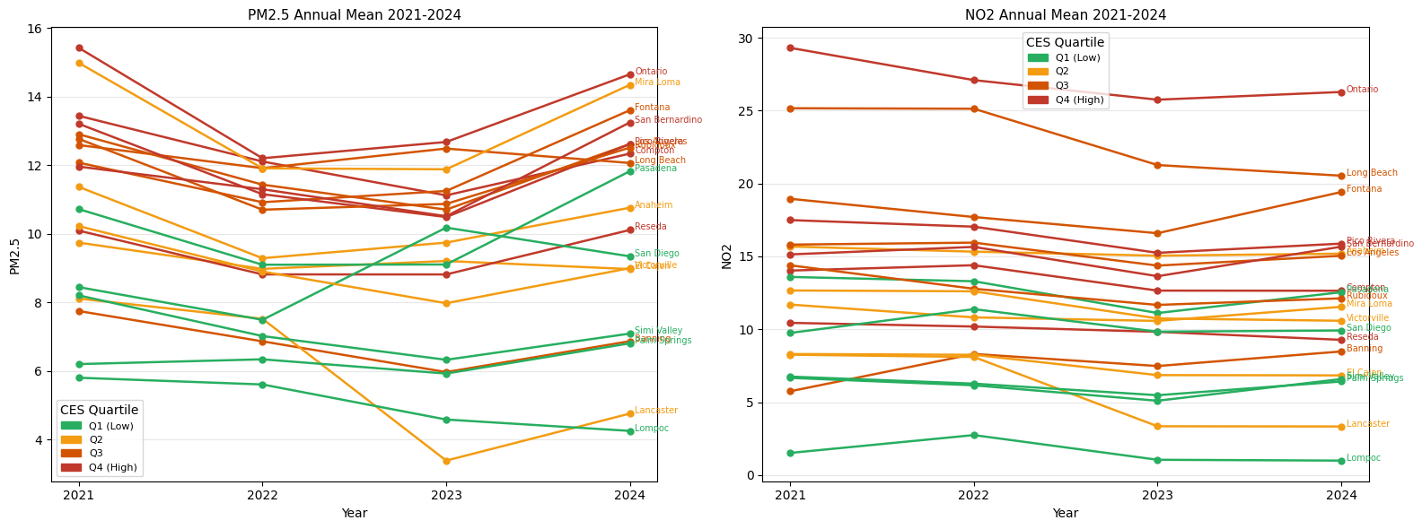
Figure 1: PM2.5 and NO2 trend lines 2021-2024, colored by CES quartile
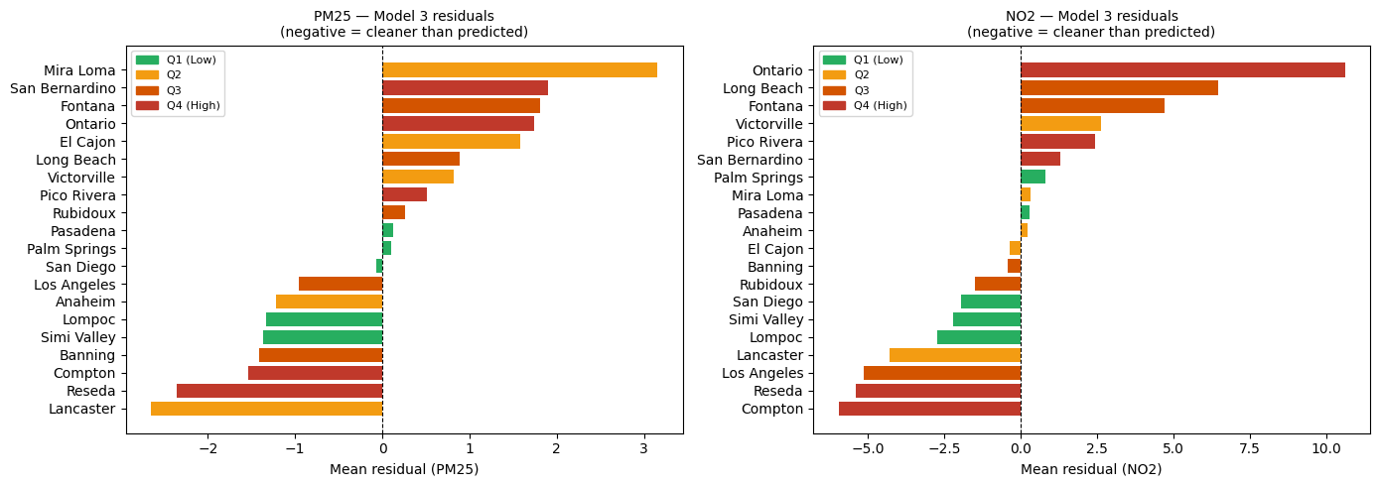
Figure 2: Model 3 residual bar charts by city, colored by CES quartiles

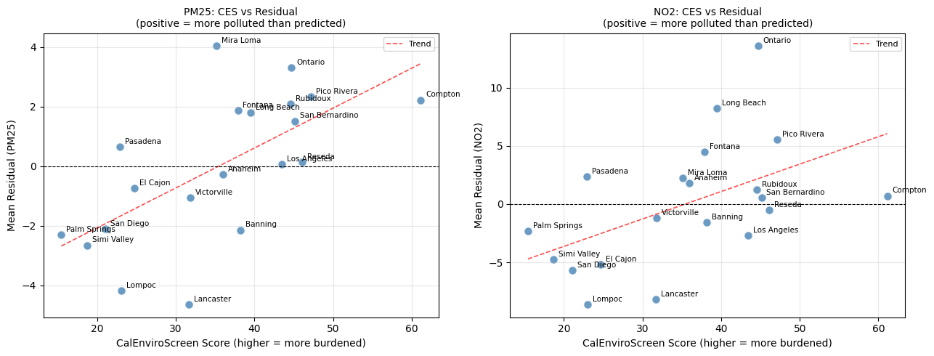
Figure 3: CES score vs. Model 3 Residuals scatter plot

Discussion

The positive ZEV coefficient shows that light-duty fleet electrification at current Southern California penetration rates (1-7% of registered vehicles) is not producing detectable air quality improvements. Garcia et al. (2023) found a nonsignificant but directionally negative NO2 association during 2013-2019 at even lower penetration; the switch to a positive association in 2021-2024 may reflect that the post-COVID traffic rebound in high adoption cities is outpacing electrification gains. This indicates a threshold where low ZEV adoption cannot offset the emissions from the conventional fleet, requiring higher market penetration to achieve net NOx reductions.
The robustness of the CES coefficient is the most important policy-related finding. Environmental burden explains a good share of cross-city air quality variation independently of any concurrent policy variables. This follows with Tessum et al’s (2019) paper that pollution inequality is structural, and with Kerr et al.’s (2021) finding that even a near-elimination of passenger traffic failed to close racial NO2 disparities because heavy-duty trucking persists. The residual analysis in this study replicates that idea at the city level, where high-pollution cities like Ontario, Mira Loma, and Fontana are systematically more polluted than the ZEV adoption and income would predict.
The non-significant equity interaction means there is no detectable differential in how ZEV adoption affects air quality across high vs low burden areas. This means that high-burden areas are not benefiting more from the ZEV adoption, but they are also not benefiting less. The structural inequity indicated by the CES coefficient is constant regardless of local ZEV penetration, and likely will continue to be unless policy addresses the freight and industrial sources that light-duty electrification does not reach. Rule 2305 (the WAIRE program) is designed for this, but its mitigation fee structure means compliance, and this does not guarantee emission reductions in specific communities bearing the burden.

Conclusion

This study estimated the relationship between localized ZEV adoption and air quality persistence across 20 Southern California cities from 2021 to 2024, and there were three main results. CalEnviroScreen burden is the most dominant predictor of both NO2 and PM2.5, and this is robust across all model specifications and consistent with the structural inequality literature. Second, ZEV adoption at current penetration rates is not associated with air quality improvement. The lagged persistence test confirms that no delayed benefit is accumulating over the one-year horizon studied. Lastly, there is no detectable equity differential in the ZEV air quality effect.
These results support Kerr et al.'s (2021) conclusion that strategies targeting heavy-duty diesel emissions are likely more effective at reducing air pollution than passenger vehicle electrification alone. Given evidence of increased ZEV adoption in high-income cities, are also consistent with Wang et al.'s (2026) concern that the adoption rate means that even if ZEVs eventually produce ambient air benefits, these benefits will accumulate in communities that need them the least.

